- \Operation\Basic settings\Operation
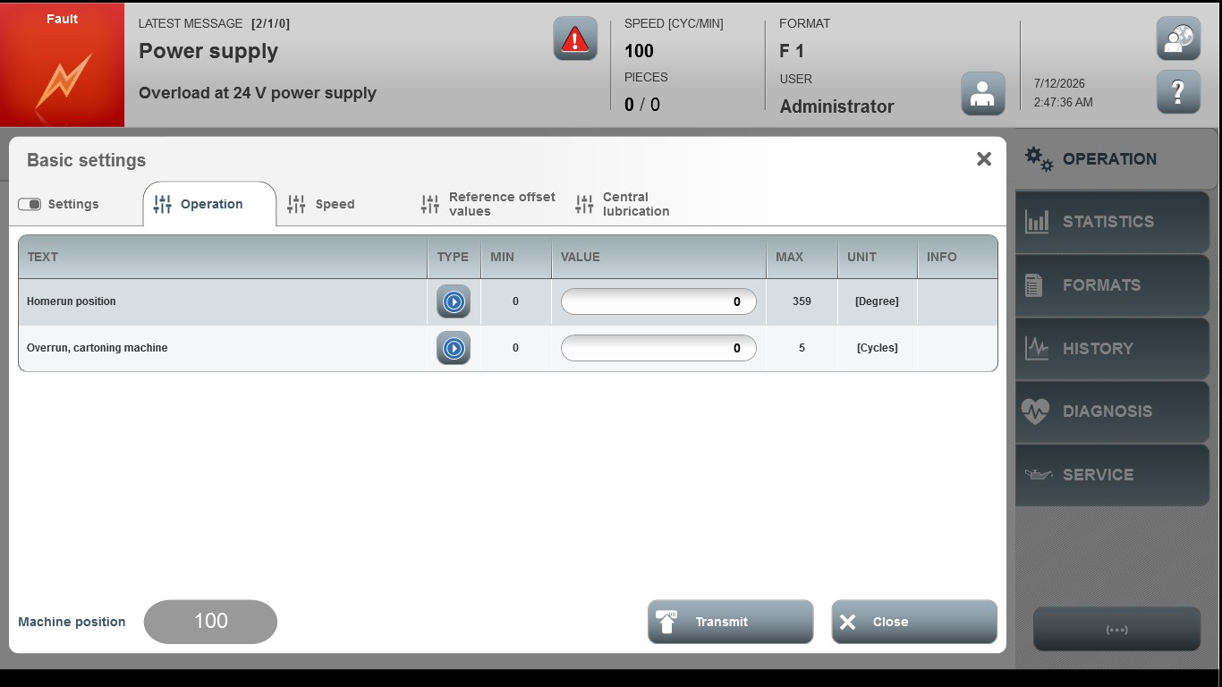
Acceptance criterion | Limits | Pass / Fail: Dev-No. | Date | Initials
Screen matches screenshot | N / A
Homerun position | 0 ... 359
Overrun, cartoning machine | 0 ... 20

